This application can be used in lieu of entering cash in PRMS AR0015-Cash Posting. It’s especially timesaving when you have remittance advice in an electronic form that can be converted into an Excel spreadsheet and there are many invoices involved.
A very specific layout is required for the INPUT sheet, but that’s overcome by setting up mapping for each customer.

Advantages of Remittance Upload:
- The remittance data is pre-edited. Correct problems before they are applied.
- Using corporate mode, invoices are auto applied to the related corporate customers.
- The application auto assigns a unique adjustment/invoice number when the input invoice does not match an existing AR invoice number. At the same time, the unidentified invoice number is saved in the AR comment field (visible in AR9008)
- An Invoice Note column is provided to add any information that is helpful in explaining unapplied cash, partial payments, adjustments, or chargebacks.
- An Excel (power-query) Historical Audit file is included. The file is updated with each transaction. The original input data is captured including a cross reference between the any auto assigned adjustment number and the original input invoice number.
- The application supports multiple companies, i.e, test and live.

Application flow:
- Select company.
- On the Main Form, click the IMPORT AR Cash, browse-to and select the INPUT xlsx sheet.
- The INPUT data is displayed in the Import Grid View.
- Click the “Validate Data” button to start the validation process.
  - Data must conform to the Excel column data types.
  - Data must conform to the AS400 expected data types and length.
  - Corporate, Customer, Invoice are validated to PRMS Master files.
  - Corporate Invoices must be related to corporate customers.
- Whether or not there are errors, you can export the validated data to a new Excel spreadsheet and view it with the open Excel button.
  - The exported Excel sheet will include a column of text of every highlighted error that you see in the data grid.
- If there are validation errors, return to your INPUT sheet, make the corrections, and repeat the upload process.
- If the validation tests pass, the “Create AR Batch” button is enabled.
- The “Create AR Batch” process will create a new AR batch for each customer/check combination.
  - In PRMS, a batch header is created along with related batch detail lines and AR invoices are updated with a pending AR amount.
  - The History file is updated for every detail transaction.
- At the conclusion of the “Create AR Batch” process, a Posted Batch form will be displayed showing the details of each AR Cash Batch that was created.
- While on the Posted Batch form, you can choose to print the same AR Posted batch information.
That concludes the Upload/Batch Creation Process, from here you can:
- Review the batch in AR0015.
- Print the batch Unposted when exiting AR0015 using AR0040.
- Post the batch immediately with AR0040.
- Review the Excel Historical file.

Screen-by-Screen
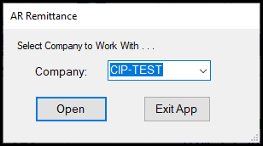
- Open the active Company (based on setup in Preferences) or Exit the Application
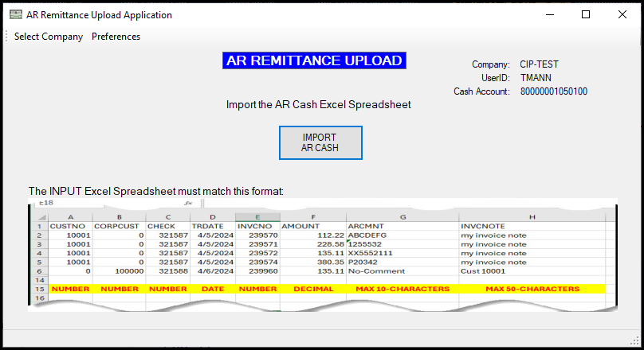
- Once you have a spreadsheet that matches the displayed format, click the Import AR Cash button, browse to, and select the Excel file.
- The imported files will show on the next form.
- Input Spreadsheet (see the Validation Process at the end of this document for editing rules)
- For those customers that provide an excel spreadsheet in their own standard format, you should create a map in excel that builds the required input format.
  - The simplest option would be to use VLOOKUP functions or copy and paste.
  - VBA can also be used to set a less manual process.
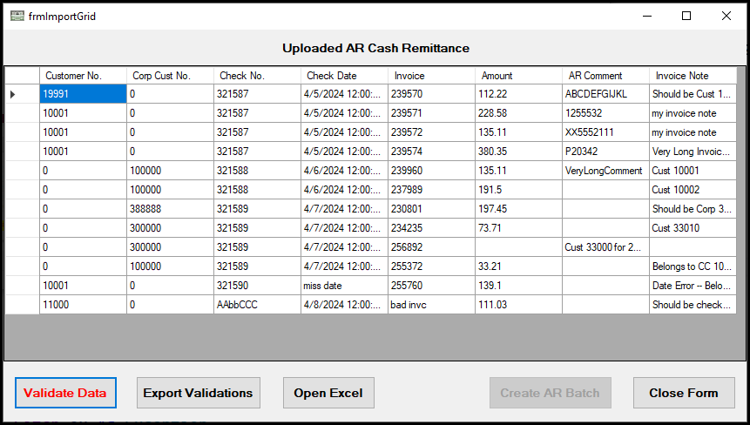
- The imported spreadsheet will show a grid view. The grid data cannot be edited.
- Click Validate Data to begin the validation process. You cannot create any batches until the validation process completes without errors.

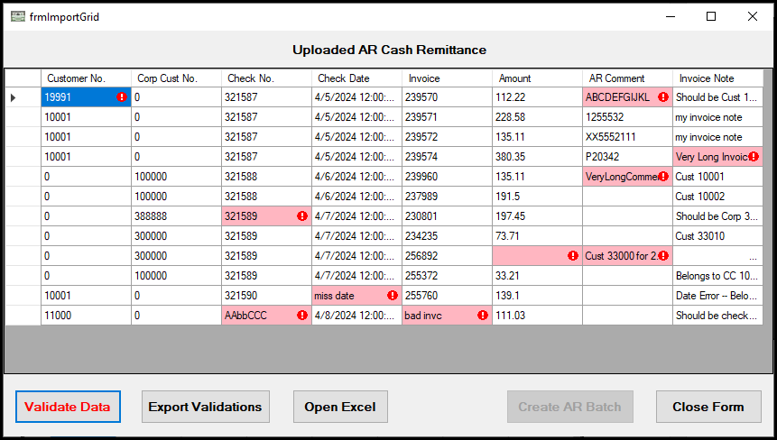
- An explanation of the error is shown by hovering the mouse over the Red Exclamation icon.
- The original spreadsheet must be corrected, then repeat the import process.
- Export Validations exports the grid to excel with a column explaining each cell error.
- Open Excel prompts you to open a spreadsheet.
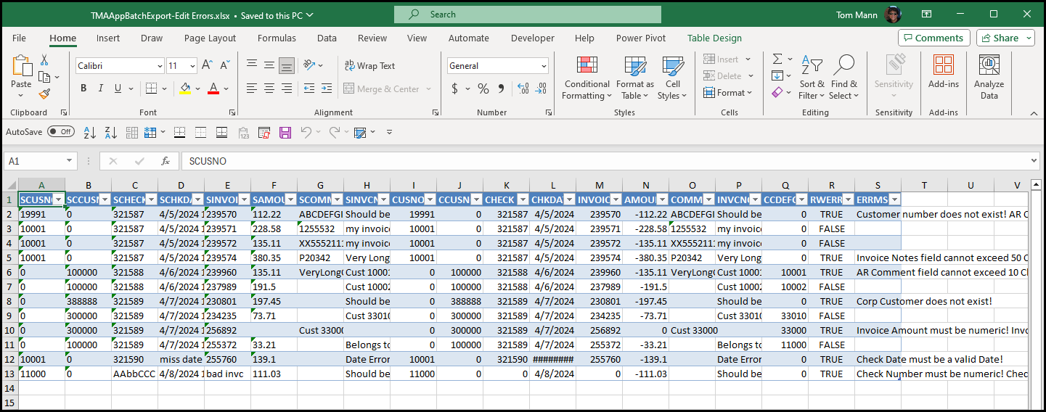
- This is the exported validation spreadsheet.
  - “TRUE” in Column R indicates that an error was present in one or more cells on that row.
  - Column S contains explanations of each error.
- One all errors have been corrected and the validation process does not find any errors, the Create AR Batch button will be enabled. Click it to create the AR Batches.
  - A separate batch will be created for each combination of Check/Customer/Corp.
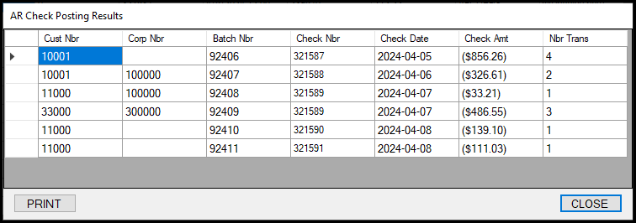
- A new form will be displayed showing details of each AR batch that was created.
- You can optionally PRINT the results.
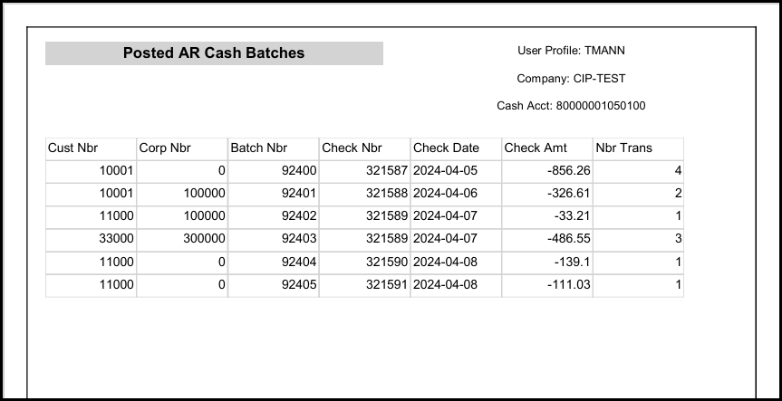

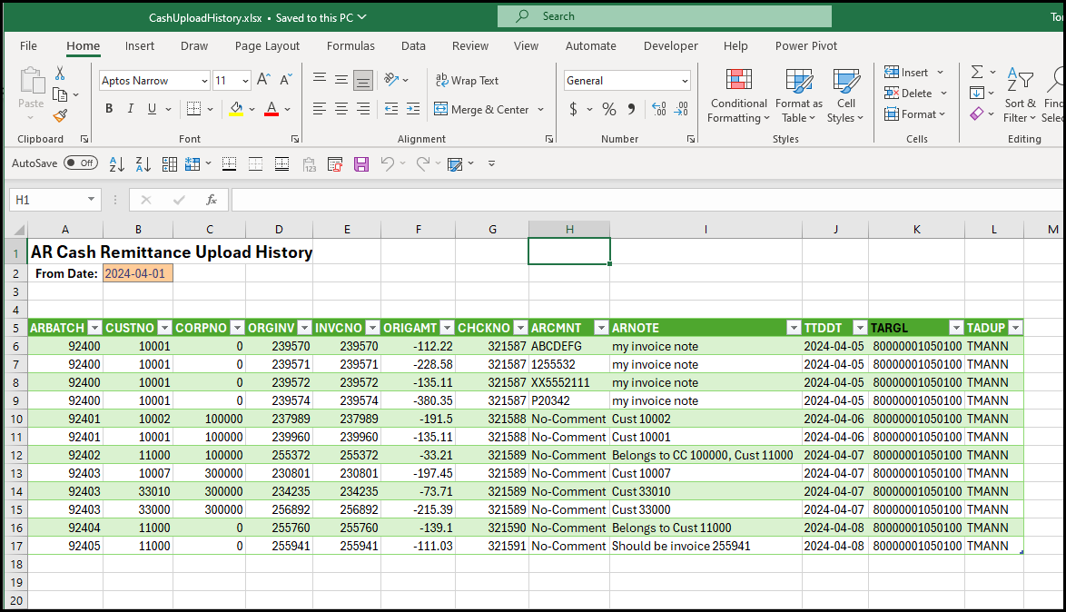
- An Excel Power Query is provided showing all cash transaction detail.
- This will be an important reference in cases where you need follow-up information that you included in the Invoice Notes. Also, there is a cross-reference if it was necessary to assign a 99xxxx adjustment for the AR Invoice.
- Optionally, change the From Date, then click on Data/Refresh ALL for the latest information.
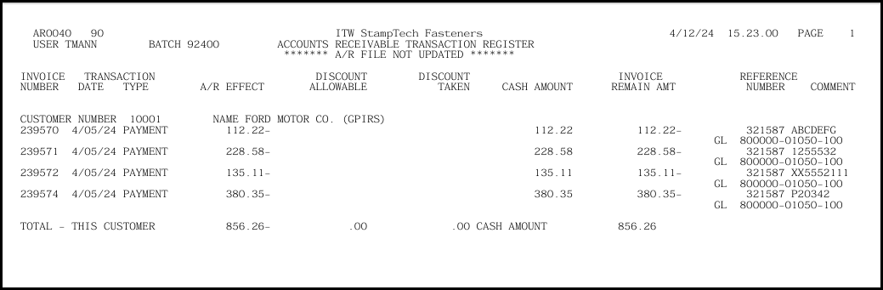
- This application DOES NOT POST BATCHES TO Accounts Receivable-It only CREATES them!
- You can use AR0015 to review and edit the batches.
- You can use AR0040 to print or post/print the batches.
- Until posted using AR0040, the transactions will show as PENDING in AR9008 inquiry.

Validation Process:
In all cases, PRMS Requires that the Invoice# be Unique 6-digit number, so there’s no working around that problem.
- If you attempt to upload an alpha-numeric invoice number, it will be rejected in the pre-edit.
- If the invoice number does not match anything in Accounts Receivable, it will be used as-is.
If the 6-digit remittance invoice is found in AR for the uploaded customer#:
- Apply the cash to the related customer’s invoice.
If the 6-digit remittance invoice is found in AR, but belongs to another customer#:
- Replace the invoice# with a 99xxxx number.
- Move the invoice# into the AR Comment field.
If the 6-digit remittance invoice is NOT found in AR for the uploaded customer#:
- Apply the cash to the related customer’s invoice.
If uploaded as a corporate number and the invoice matches a related customer account:
- Apply the cash to the related customer’s invoice.
If uploaded as a corporate number and the invoice matches an Unrelated customer account:
- Replace the invoice# with a 99xxxx number.
- Move the invoice# into the AR Comment Field.
- Post to the FIRST related customer for the entered corporate number.
If uploaded as a corporate number and the invoice does NOT match any related customer account:
- Replace the invoice# with a 99xxxx number.
- Move the invoice# into the AR Comment Field.
- Post to the FIRST related customer for the entered corporate number.

Note: the Excel Power Query Transaction History will show all postings, including any newly assigned 99xxxx numbers cross-referenced to the bad uploaded invoice# and any invoice notes that were included in the original cash batch upload.

